**DESIGN AND DEVELOPMENT OF FULLY AUTONOMOUS CREWLESS PROTOTYPE MODEL SHIP**

***Project Report Submitted by***

**DEVIS VIJITH KARKADA NISARGA**

**4NM19ME409 4NM19ME423**

**JOSHUA DSOUZA HARSHA P SHETTY**

**4NM18ME057 4NM18ME052**

**Under The Guidance of**

**Dr. Nithin Kumar**

**Associate Professor**

***in partial fulfillment of the requirements for the award of the Degree of***

**Bachelor of Engineering (Mechanical)**

***from***

***Visvesvaraya Technological University, Belagavi***

**DEPARTMENT OF MECHANICAL ENGINEERING**

**June 2022**

**Department of MECHANICAL Engineering**

CERTIFICATE

Certified that the project work entitled

*“***DESIGN AND DEVELOPMENT OF FULLY AUTONOMOUS CREWLESS PROTOTYPE MODEL SHIP**”

*is a Bonafide work carried out by* **Devis Vijith Karkada (4NM19ME409), Nisarga (4nm19me423), Joshua Dsouza (4nm18me057) and Harsha P Shetty (4nm18me052)**

*in partial fulfillment of the requirements for the award of*

***Bachelor of Engineering Degree*** *in* **Mechanical Engineering**

*prescribed b*y **Visvesvaraya Technological University, Belagavi**

*during the year 2021-2022.*

*It is certified that all corrections/suggestions indicated for Internal Assessment have been incorporated in the report deposited in the departmental library.*

*The project report has been approved as it satisfies the academic requirements in respect of the project work prescribed for the Bachelor of Engineering Degree.*

**Signature of Guide(s) Signature of HOD Signature of Principal**

**ACKNOWLEDGEMENT**

We take this opportunity to express my deep sense of gratitude to our guide **Dr. Nithin Kumar**, Associate Professor, Department of Mechanical Engineering, NMAMIT, Nitte for his whole-hearted support and valuable guidance he has given us during project part 1.

We convey our sincere regards to **Dr. Srinivasa Pai P.,** Professor & Head, Department of Mechanical Engineering, NMAMIT, Nitte for encouraging us during the project tenure.

Our grateful thanks to **Dr. Niranjan N. Chiplunkar,** Principal, NMAMIT, Nitte for his inspiration and support while carrying out the project work.

We cordially acknowledge and give due credit to **Mr.** **Parashuram K (SMI) 6 KAR NAVAL UNIT UDUPI,** and our friends and family for the constant support  
they have extended to us and the faith they have shown in me during the tenure of this  
mini project and finally to God who made all the things possible for us till the end.

**ABSTRACT**

The study provides both a spherical understanding about autonomous ship navigation for collision avoidance (CA) and a theoretical background of the reviewed work. The requirements for autonomous ship navigation are addressed in conjunction with the factors influencing ship collision avoidance. Humans can appreciate these factors and perform ship navigation at a satisfactory level, but their critical decisions are highly subjective and can lead to error and potentially, to ship collision.

A simple approach for obstacle detection and collision avoidance of an autonomous ship using ultrasonic sensors, gyroscope, brushless motors, servo motors, and microcontroller is presented here. In this project, a prototype model of crew-less ship is designed. The concept of the project was inspired by the recent surge in autonomous ship concepts in the shipping industry.

**Contents**

|  |  |  |  |
| --- | --- | --- | --- |
|  |  | | Page No. |
| Acknowledgement |  | | iii |
| Abstract |  | | iv |
| Contents |  | | v |
| List of figures |  | | vii |
|  |  | |  |
|  |  | |  |
| Chapter 1 | Introduction | | 1-8 |
|  | 1.1 | Introduction | 1 |
|  | 1.2 | Product Components and description  1.2.1 APM 2.8 flight controller  1.2.2 Raspberry pi zero  1.2.3 External GPS  1.2.4 Pi Cam 5mp with ribbon cable  1.2.5 RC Kit (Transmitter and receiver)  1.2.6 Brushless motor 2200KV  1.2.7 ESC Electronic Speed controller  1.2.8 Servo Motor  1.2.9 Lipo Battery 11.1V | 1  1  2  3  4  5  6  6  7  7 |
|  |  |  |  |
| Chapter 2 | Literature review | | 9-10 |
|  | 2.1 | Introduction | 9 |
|  | 2.2 | Literature review | 9 |
|  |  |  |  |
| Chapter 3 | Objective and problem definition | | 11 |
|  | 3.1 | Objective and problem definition | 11 |
|  |  |  |  |
| Chapter 4 | Methodology and proposed work | | 12-19 |
|  | 4.1 | Introduction | 12 |
|  | 4.2 | Project layout | 12 |
|  | 4.3 | Engineering setup | 13 |
|  |  | 4.3.1 Servo | 13 |
|  |  | 4.3.2 Brushless Motor | 13 |
|  |  | 4.3.3 GPS | 14 |
|  |  | 4.3.4 microcontroller unit | 14 |
|  |  | 4.3.5 Raspberry pi Zero | 14 |
|  |  | 4.3.6 Pi camera | 15 |
|  |  | 4.3.7 RC receiver | 15 |
|  |  | 4.3.8 4G Router | 16 |
|  | 4.4 | Identifying the components | 16 |
|  | 4.5 | Hardware and software | 17 |
|  |  | 4.5.1 Hardware used | 17 |
|  |  | 4.5.2 Software used | 17 |
|  | 4.6 | Sensor circuit | 18 |
|  |  | 4.6.1 HC-SR04 | 18 |
|  |  | 4.6.2 JSN-SR04T | 18 |
|  |  | 4.6.3 GY-521 | 19 |
|  |  |  |  |
| Chapter 5 | Fabrication and experimentation | | 20-25 |
|  | 5.1 | Introduction | 20 |
|  | 5.2 | Conceptual design | 20 |
|  | 5.3 | Work done | 21 |
|  | 5.4 | Fabrication of model | 21 |
|  |  | 5.4.1 Planning of design and dimensions | 21 |
|  |  | 5.4.2 Selection of materials to construct  vessel | 22 |
|  |  | 5.4.3 Laying of keel | 22 |
|  |  | 5.4.4 Construction of hull | 23 |
|  |  | 5.4.5 Construction of super structure | 24 |
|  | 5.5 | Setup and configuration | 25 |
|  |  |  |  |
| Chapter 6 | Result and discussion | | 27-28 |
|  | 6.1 | Result and discussion | 27 |
|  |  |  |  |
| Chapter 7 | Conclusion and scope of future work | | 29-30 |
|  | 7.1 | Conclusion | 29 |
|  | 7.2 | Scope of future work | 29 |
|  |  |  |  |
| References |  |  | 31 |

**List of Figures**

|  |  |  |
| --- | --- | --- |
| **Figure No.** | **Figure Title** | **Page No.** |
| 1.1 | APM 2.8 | 2 |
| 1.2 | Raspberry Pi | 3 |
| 1.3 | APM GPS MODULE | 4 |
| 1.4 | Pi Camera with ribbon cable | 5 |
| 1.5 | RC Kit | 5 |
| 1.6 | Brushless Motor | 6 |
| 1.7 | Electronic Speed Controller (ESC) | 7 |
| 1.8 | Servo Motor | 7 |
| 1.9 | Lipo Battery | 8 |
| 4.1 | Layout | 12 |
| 4.2 | Telemetry | 12 |
| 4.3 | Engineering setup | 13 |
| 4.4 | Sensor Circuit | 18 |
| 5.1 | Isometric view | 21 |
| 5.2 | Top view | 21 |
| 5.3 | Side view | 21 |
| 5.4 | Laying of Keel | 22 |
| 5.5 | Metal paste stage | 23 |
| 5.6 | Primer stage | 23 |
| 5.7 | Painting hull | 24 |
| 5.8 | Hull | 24 |
| 5.9 | Superstructure | 25 |
| 5.10 | Completed prototype model | 25 |
| 5.11 | Setup and configuration | 26 |
| 6.1 | Pitch, roll and yaw | 28 |
| 6.2 | GUI interface | 28 |

**CHAPTER 1**

**INTRODUCTION**

* 1. **INTRODUCTION**

A crew-less ship can sense its environment and operating by operator at seashore. Presence of crew or sailor not required in ship (onboard). Automated ship uses a range of sensors to scan its surroundings and feed the information to the NodeMCU, which processes the information and then relay the sailing instructions. Indeed, supposing that no personal will be onboard no more human error would occur, no crew would get injured. The project, miniature version of the vessel highlights how transportation is increasingly shifting toward automation, and sailor-less ship would be managed from land-based facilities focusing on specific task.

This crew-less ship concept was taken from “THE INTERSEPTOR – Crewless ship” which was done in the year 2010 as a part of REPUBLIC DAY CAMP as an open class model. In reference to this, thought an idea to modify the concept of INTERCEPTOR from remote control to autonomous.

* 1. **PRODUCT COMPONENTS AND DESCRIPTION**

**1.2.1 APM 2.8 FLIGHT CONTROLLER**

The **APM 2.8 Multi copter Flight Controller** is a complete open source autopilot system.  =This is the best-selling technology that won the prestigious Outback Challenge UAV competition. It allows the user to turn any fixed, rotary-wing. In addition, it turns **multi-rotor vehicles (even cars and boats) into a fully autonomous vehicle. Meanwhile, it is capable of performing programmed GPS missions with waypoints.**

The flight controller uses the data gathered by the sensors to calculate the desired speed for each of the four motors.The flight controller sends this desired speed to the Electronic Speed Controllers (ESC’s), which translates this desired speed into a signal that the motors can understand. This flight controller

APM 2.8 Multi copter Flight Controller is an upgraded version of 2.5 and 2.6 with a Built-in Compass for FPV RC Drone. The sensors are exactly the same as the APM 2.6 flight controller. However, the module has the option to use the built-in compass an external compass via a jumper. This makes the APM 2.8 ideal for use with multi-copters and rovers.

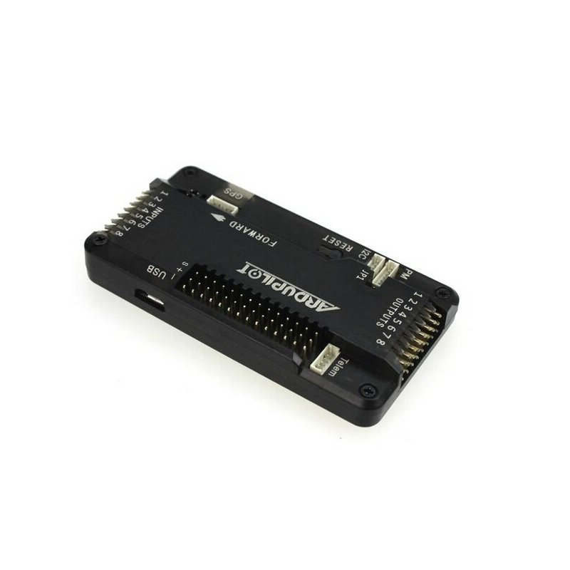

***Fig. 1.1*** *APM 2.8*

**1.2.2 RASPBERRY PI ZERO**

The Raspberry pi zero WH is another member of Raspberry pi Zero family. It adds wireless connectivity and comes with pre-soldered 40-pin header, hence WH designation. The Raspberry Pi Zero family is the smallest, slimmest and lowest cost Raspberry Pi to date. It's about half of the Pi A+ size. It comes with a mini HDMI port for audio/video instead of the regular HDMI port on other models. There is no standard USB port, but there is a micro USB OTG port instead. The pi zero w has been designed to be as flexible and compact as possible with mini connectors and unpopulated 40-pin GPIO, allowing you to use only what your project requires. At the heart of the Raspberry pi zero w is a 1GHz BCM2835 single core processor with 512MB RAM.

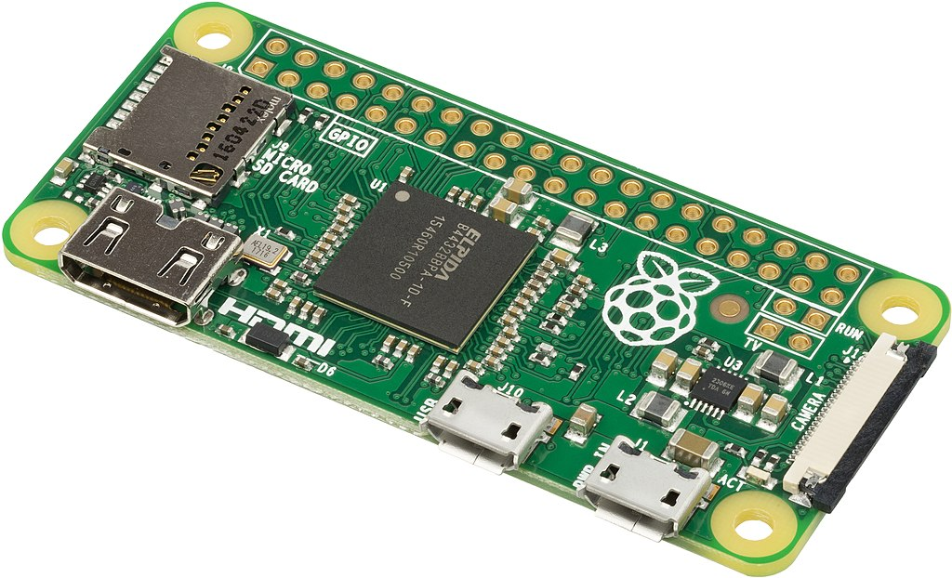

***Fig. 1.2*** *Raspberry Pi*

**1.2.3 External GPS**

GPS drones are equipped with a GPS module that allows them to know their location relative to a network of orbiting satellites. Connecting to signals from these satellites allows the drone to perform functions such as position hold, autonomous flight, return to home, and waypoint navigation.

NEO-M8N High Precision GPS Module with Built-in Compass for APM and PIXHAWK FC is the new Neo-M8N GPS module that includes an HMC5883L digital compass. This module has a high level of sensitivity and features active circuitry for the ceramic patch antenna. It also comes enclosed in a plastic case to protect the module from the elements. This module outputs precise position updates at **10Hz**and also has a rechargeable backup battery for warm starts. The **NEO-M8N** is configured to run at a **baud rate of 38400** and can be used with Pixhawk and APM (you might need to modify the cable to fit your autopilot board).

NEO-M8N GPS Module for **APM2.52** Flight Controller with Case and GPS Antenna Mount to protect the GPS preventing electromagnetic interference. A new generation **NEO-M8N GPS** Module, with low power consumption and high precision, the ultimate accuracy **is 0.6 meters**, actually almost **0.9 meters**, greater than the previous generation **NEO-7N 1.4-1.6** meters accuracy. Support **GPS/QZSS L1 C/A, GLONASS L10F** mode or more. The **NEO-M8N** and ceramic antenna make this a very accurate receiver, fast locks & lots of satellites, and the stand is very sturdy to protect the GPS preventing electromagnetic interference.

The most important improvement with this module is the vast sensitivity it offers. This module receives concurrent reception from **GPS/QZSS, GLONASS**, meaning that you should get an excellent signal no matter where you are in the world. Not only does it have these excellent reception capabilities, but it also maintains its low power consumption. This module is also backward compatible with the **NEO-7, NEO-6, and NEO-5** families.

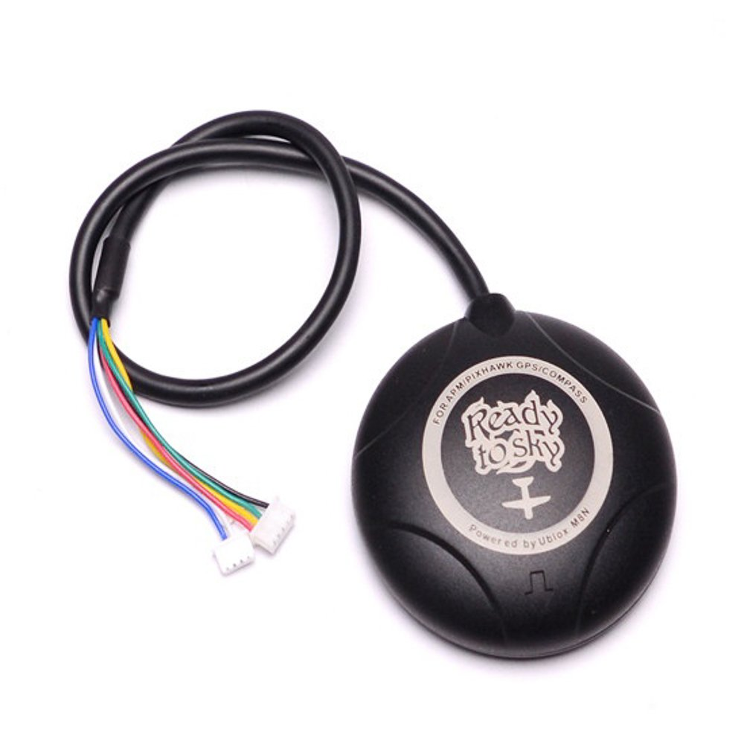

***Fig. 1.3*** *APM GPS MODULE*

**1.2.4 Pi cam 5mp with ribbon cable**

The 5MP camera module is perfect for small Raspberry Pi projects which have very little space allowance just boot up the latest version of Raspbian and you are good to go. The high-definition 5MP camera delivers outstanding photos but can also shoot video, ideal for drones or a CCTV project. The lightweight camera board allows for it is useful in more practical roles, such as a hidden camera, even a camera for a Pi-phone. This Raspberry Pi Camera Module is a custom designed add-on for Raspberry Pi. It attaches to Raspberry Pi by way of one of the two small sockets on the board upper surface. This interface uses the dedicated CSI interface, therefore it is designed especially for interfacing to cameras. The CSI bus is capable of extremely high data rates, and it exclusively carries pixel data.

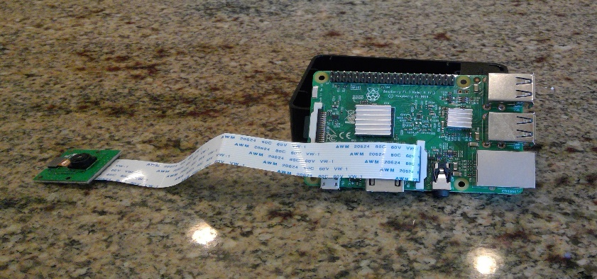

***Fig. 1.4*** *Pi Camera with ribbon cable*

**1.2.5 RC kit (Transmitter and receiver)**

A radio frequency transmitter-receiver board receives data and transmits it wirelessly to different components via its antenna.

Transmitter: The remote control contains a radio transmitter which operates on a particular frequency that the receiver is designed to receive.

Receiver: The receiver is fixed within the car and constantly receives signals from the transmitter. When a transmission is identified, it translates the number of electrical pulses into action.

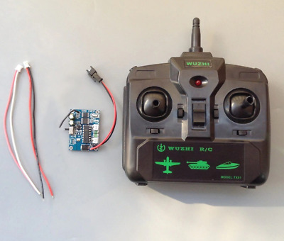

***Fig. 1.5*** *RC Kit*

**1.2.6 Brushless motor 2200KV**

This A2212/6T 2200KV Brushless DC Motor for RC Quadcopters Planes Boats Vehicles and DIY Kits. 6T (BLDC) BRUSHLESS DC MOTOR is one of the most popular high-speed brushless motor designed specifically for RC hobbyists. The motor is out runner type where outside case rotates while inside stays fixed. It is one of the popular models in the market because it’s low cost. It is preferred for small drones and planes. The motor features a 3.17mm hardened steel shaft and dual ball bearings for a smooth and steady rotating motion. A bullet type propeller adapter and cross motor mount are included. As it is a 3-phase motor, speed and efficiency are high. It comes with a motor mount, dome-type alloy prop spinner/adaptor, screws and 3.5mm banana connectors (Bullet plugs).

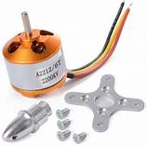

***Fig. 1.6*** *Brushless Motor*

**1.2.7 ESC Speed controller 30Amps**

An electronic speed control (ESC) is an electronic circuit that controls and regulates the speed of an electric motor. It may also provide reversing of the motor and dynamic braking. Miniature electronic speed controls are used in electrically powered radio controlled models. Full-size electric vehicles also have systems to control the speed of their drive motors. Standard BLDC 30 amp ESC Electronic Speed Controller with Connector is specifically made for quadcopters and multi-rotors. It provides faster and better motor speed control giving better flight performance compared to other available ESCs.

STANDARD 30 amp ESC Electronic Speed Controller can drive motors that consume up to 30A current. It works on 2-3S LiPo batteries. The onboard BEC provides regulated 5V(2A max draw) to power the flight controller and other onboard modules. This is useful to control our brushless motors with a 2-3S LiPo

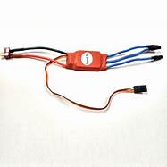

***Fig. 1.7*** *Electronic Speed Controller (ESC)*

* + 1. **Servo motor**

A servo motor (servo motor) is a rotary actuator or linear actuator that allows for precise control of angular or linear position, velocity and acceleration.  It consists of a suitable motor coupled to a sensor for position feedback. It also requires a relatively sophisticated controller, often a dedicated module designed specifically for use with servomotors.

Servomotors are not a specific class of motor, although the term servomotor is often used to refer to a motor suitable for use in a closed-loop control system. Servomotors are used in applications such as robotics, CNC machinery, and automated manufacturing.

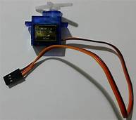

***Fig. 1.8*** *Servo Motor*

**1.2.9 Lipo battery 11.1v**

A lithium-polymer battery (LiPo) is a rechargeable battery that, in the case of true LiPo, uses solid polymer for the electrolyte and lithium for one of the electrodes. Commercially available LiPo are hybrids: gel polymer or liquid electrolyte in a pouch format, more accurately termed a lithium ion polymer battery.

True LiPo batteries have not reached commercial viability. The batteries referred to as LiPo in commercial use offer reduced thickness, flexibility and weight.

Their qualities make LiPo batteries suited to thin smartphones, tablets and wearables. While LiPo made a splash in radio-controlled hobbies and still remain an option, LiIon (lithium ion) are making a return due to their better discharge abilities. While pouch-type standard LiIon batteries exist, they still require external casing to prevent expansion that would otherwise become a performance and safety issue.

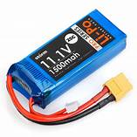

***Fig. 1.9*** *Lipo Battery*

**CHAPTER 2**

**LITERATURE REVIEW**

* 1. **INTRODUCTION**

This chapter provides details of background theory on crewless ship and observations from the literature review have been carried out.

* 1. **LITERATURE REVIEW**

Xiang-yu Zhou. et.al. [1] COLREGs are the regulations to prevent collisions in the sea followed by manned vessels currently operating in the sea. Autonomous ships following these regulations is an aspect that some experts are skeptical about. The authors analyze the rules provided by COLREGs on how autonomous ships will follow them and what are the limitations. The research concluded that there are no unsurmountable obstacles in COLREGs for the autonomous ships to operate. However, some further revisions and elaborations are needed to eliminate uncertainties of interpretation.

Goran Vojković. et.al [2] Autonomous ships will undoubtedly revolutionize the shipping industry, but existing legal framework presents challenges for both autonomous and remote-controlled ships. Autonomous ships which will be fully controlled by Artificial Intelligence changes the role of ship master which has developed over centuries. The ship’s master authorities are divided into three segments: the public authorities, the duties of the ship’s safety and navigation, and representing shipping companies. If the ship master is not physically onboard, like in autonomous or remotely controlled ships, the power changes considerably.

Timothy J. McCoy [3] Electric ships are a perfect candidate of autonomization or remotely controlling as the power units are more easily controllable. This article provides details about shipboard power and propulsion systems, history of electrification of ships and hurdles faced during the process in terms of power and energy requirements.

Ziaul Haque Munim [4] While Norway is pioneering the technological development of autonomous ships, other countries such as China, Finland and USA have also made significant progress. However, future applications of autonomous ships and potential business models are not yet well explored. Soon, autonomous ships are expected to be launched commercially, adding a new dimension in the merchant shipping industry. Thus, this study contributes to the maritime literature by (1) providing a review of the autonomous ship development projects and the benefits of autonomous ships from an economic, environmental, and social perspective, (2) suggesting innovative uses of autonomous ships in short-sea-shipping (SSS), arctic shipping, and conventional shipping, and finally (3) discussing potential business models from the perspective of autonomous ship manufacturers.

Kurt Schwehr [5] Autonomous Identification System (AIS) is an automated vessel tracking system that displays the information about other vessels in the vicinity. It is a broadcast transponder system that operates in VHF mobile maritime band. Real-time AIS and e-Navigation related technologies enable closer coordination between all involved parties.

Recorded historical AIS data give insight into what occurred before, during, and after an incident. Historical AIS analysis facilitates planning for future situations by creating a baseline model of operational procedures, as they currently exist. Mariner and responder safety can be an issue from sudden and drastic alteration of ship traffic patterns caused by emergencies.

M.A. Ramos et.al. [6] Although the human role is reduced, autonomous ships would still rely on operators for supervision, remote control, and involvement in case of a glitch or an unexpected situation. Thus, autonomous ships do not fully eliminate the possibility of human error. This study assesses the potential for human error in autonomous ship operations. An unmanned autonomous ship operation is analyzed, and through a generic analysis of the interaction between operators working a Shore Control Centre (SCC) and system, possible Human Failure Events are identified.

Andrzej Felski and Karolina Zwolak [7] Whenever a new technology is introduced, there will be some skepticism regarding the threats it poses. In this study, the possible threats autonomous ships will pose to other ship users and the security of the autonomous ship itself and cargo or equipment on board are discussed.

**CHAPTER 3**

**OBJECTIVE AND PROBLEM DEFINITION**

**3.1 OBJECTIVE AND PROBLEM DEFINITION**

A job on a vessel is considered one of the most dangerous jobs in the world. To increase safety of Sea way and seafarers, autonomous ships are under development. The scope of this project includes converting a ship with crew on board to ship without crew on board i.e. automatic. The safety of the ship’s crew from pirate hijacking, mental problems, storms and hurricane, human error in different weather conditions is of the utmost concern. Also, to mitigate the scarcity of food, medicine, and other requirements on board.

In this project a low-cost prototype of sailor-less ship is proposed.

The ship will have a range of sensors on board, a computer program can detect traffic and drift in the course of the ship due to ocean currents and wind and give correct decisions (turn port side, turn starboard side, stop) to the ship such that the ship will autonomously travel from start to destination without any human intervention following the preset path followed in the international and territorial waters.

The objectives set to be achieved on completion of this project are as follows,

* To create fully autonomous prototype miniature model ship.
* To fabricate a prototype miniature model of a ship.
* To implement drone autopilot system to surface vessel.
* To implement obstacle detection system.
* To design a hull that can house all the components.
* To fabricate the hull and fine tune its stability.
* To achieve highest gps accuracy as possible.
* Testing and tuning of the model ship.

**CHAPTER 4**

**METHODOLOGY OF PROPOSED WORK**

**4.1 INTRODUCTION**

In this chapter discusses about the general project layout, engineering setup of this project and its functioning, hardware and software used and the sensor layout.

**4.2 PROJECT LAYOUT**

Telemetry

Ground station

Autonomous ship

***Fig 4.1*** *Layout*

We need a ground station to send missions and to have a controlled environment to when the ship is in tough condition or a manual interference is needed. The telemetry is needed to communicate with the ship. There are various type of telemetry we can use which are convenient to the situation and to the purpose of use. And fabrication and components of the ship needs to be done.

As ground station we will be using Ardupilot, which will be sending missions and it will be calibrating various parameter of the model ship. Ship is equipped with gps which can locate the ship in real-time.

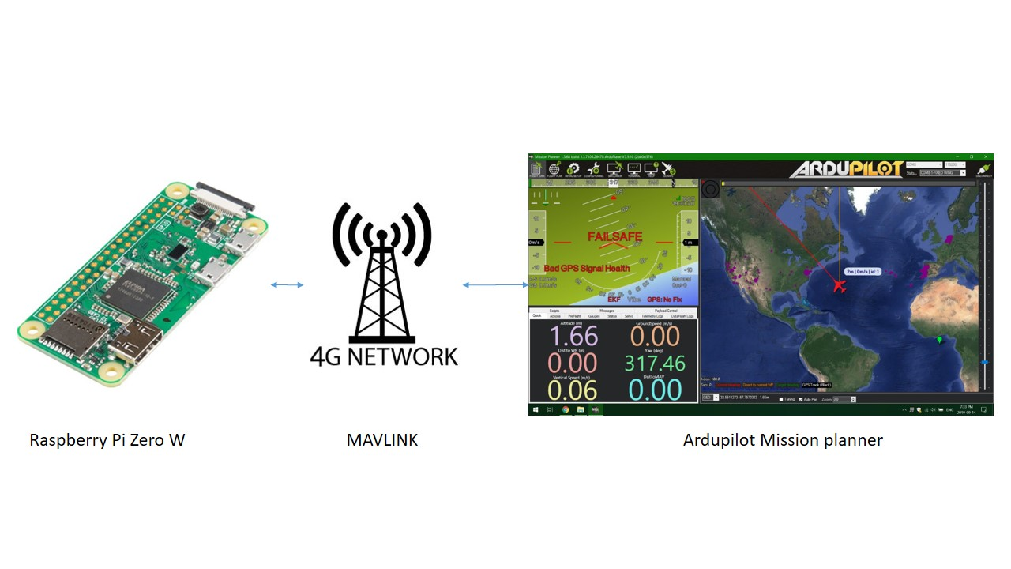

***Fig.4.2*** *Telemetry*

**4.3 ENGINEERING SETUP**

RC Receiver

GPS

Servo

Micro Controller Unit

Brushless

4G router

Raspberry pi zero

Lipo

Power bank

Pi camera

***Fig.4.3*** *Engineering setup*

The engineering setup of the components used in this project is shown in Fig. __. The functioning of each is as follows,

**4.3.1 Servo**

A servomotor is a [closed-loop](https://en.wikipedia.org/wiki/Closed-loop_controller) [servomechanism](https://en.wikipedia.org/wiki/Servomechanism) that uses position feedback to control its motion and final position. The input to its control is a signal (either analogue or digital) representing the position commanded for the output shaft.

The motor is paired with some type of [position encoder](https://en.wikipedia.org/wiki/Encoder_(position)) to provide position and speed feedback. In the simplest case, only the position is measured. The measured position of the output is compared to the command position, the external input to the controller. If the output position differs from that required, an [error signal](https://en.wikipedia.org/wiki/Error_signal) is generated which then causes the motor to rotate in either direction, as needed to bring the output shaft to the appropriate position. As the positions approach, the error signal reduces to zero and the motor stops.

**4.3.2 Brushless**

A brushless DC motor (also known as a BLDC motor or BL motor) is an electronically commuted [DC motor](https://www.electrical4u.com/dc-motor-or-direct-current-motor/) which does not have brushes. The controller provides pulses of [current](https://www.electrical4u.com/electric-current-and-theory-of-electricity/) to the motor windings which [control the speed](https://www.electrical4u.com/speed-control-of-synchronous-motor/) and torque of the [synchronous motor](https://www.electrical4u.com/synchronous-motor-working-principle/). The brushless is used to drive then propeller of the model ship.

**4.3.3 GPS**

GPS is a system. It’s made up of three parts: satellites, ground stations, and receivers.

Satellites act like the stars in constellations—we know where they are supposed to be at any given time.

The ground stations use radar to make sure they are actually where we think they are. The receiver figures out how far away they are from some of them.

Once the receiver calculates its distance from four or more satellites, it knows exactly where you are. Presto! From miles up in space your location on the ground can be determined with incredible precision! They can usually determine where you are within a few yards of your actual location. More high-tech receivers, though, can figure out where you are to within a few inches!

GPS is a system of 30+ navigation satellites circling Earth. We know where they are because they constantly send out signals. A GPS receiver in your phone listens for these signals. Once the receiver calculates its distance from four or more GPS satellites, it can figure out where you are.

**4.3.4 Micro Controller Unit**

Microcontrollers are embedded inside devices to control the actions and features of a product. Hence, they can also be referred to as [embedded controllers](https://www.intervalzero.com/overview-rtos-rtx64-and-rtx/). They run one specific program and are dedicated to a single task. They are low power devices with dedicated input devices and small LED or LCD display outputs. Microcontrollers can take inputs from the device they controlling and retain control by sending the device signals to different parts of the device.

**4.3.5 Raspberry pi zero**

A Single-Board Computer (SBC) is a complete, functioning computer in which the microprocessor, input/output functions, memory, and other features are all built on a single circuit board, with RAM built in at a pre-determined amount and with no expansion slots for peripherals.

This dramatically simple infrastructure design can seem antithetical to the multiple configurations offered in current personal computers, but that simplicity results in dependability that makes SBCs perfect as an embedded computer controller used to operate complex autonomous system.

SBCs are the preferred computer for running vital "always on" missile guidance systems, traffic light controllers, automotive anti-lock braking and stability control systems, medical imaging systems, etc. It also makes them preferred in consumer goods, like cell phones, video game consoles, appliances, and more.

The Single-Board Computer (SBC) is a preferred embedded controller for a wide range of industries, having consumer, industrial, smart home, automotive, appliance, medical, commercial, and military applications. But if there is one word that unites all of these categories, it is...reliability. The single most important quality SBCs deliver, in each category, is its long, proven record of reliable performance.

**4.3.6 Pi camera**

The Raspberry Pi Camera Board is a custom designed add-on module for Raspberry Pi hardware. It attaches to Raspberry Pi hardware through a custom CSI interface. The sensor has 5-megapixel native resolution in still capture mode. In video mode it supports capture resolutions up to 1080p at 30 frames per second. The camera module is light weight and small making it an ideal choice for mobile projects.

The camera board attaches to the Raspberry Pi via a ribbon cable. One end of the ribbon cable goes to the camera PCB and the other end attached to Raspberry Pi hardware itself. You need to get the ribbon cable connections the right way, or the camera will not work. On the camera PCB, the blue backing on the cable should be facing away from the PCB, and on the Raspberry Pi hardware it should be facing towards the Ethernet connection.

**4.3.7 RC Receiver**

Recent developments have provided a new and more secure frequency - 2.4GHz - for use with radio controlled models. Basically, 2.4G technology allows the transmitter and receiver to be 'locked-on' to the same frequency ensuring much improved reliability and peace of mind when operating. Operating at 2.4 Gigahertz puts the radio control out of the frequency range of any 'noise' caused by the other electronic components on your helicopter - such as the motor, speed controller and any metal to metal noise - eliminating interference and glitching that can affect a 35 megahertz system.

Instead of transmitting on one channel at a time, both the transmitter and receiver are constantly hopping from channel to channel - at over 1000 times a second! When you initially 'pair' your transmitter to your receiver, they initiate the synchronised sequence of channel hopping.

With 2.4GHz effectively 40 channels are available and the sets automatically set themselves to an unused frequency when switched on. Operation is constantly self-monitored and the set will move to an unused frequency if any interference is detected.  
Because 2.4G RC systems work on higher frequency short wave length, the transmitter antenna is only about 15cm long and flexible - avoiding bends and breakages that can occur with traditional 35Mhz telescopic aerials! The receiver antenna is much shorter too - allowing for much neater installation of the radio gear in the helicopter.

**4.3.8 4G router**

Providing internet connection without cable restrictions, 4G routers are convenient and widely popular in the networking market. A 4G WiFi router, containing a built-in LTE broadband modem, uses a SIM card to share internet connections. You can use a 4G WiFi router for internet sharing anywhere, as long as it is within the network range of the network service provided by your mobile operator.

4G Wi-Fi router supports two operation modes: 3G/4G Router mode and Wireless Router mode. In Wireless Router mode, you can use 3G/4G networks as backup internet if your broadband connection fails. On the other hand, you can flexibly turn to fixed networks in case your mobile networks are less stable. 3G/4G Router Mode: In this mode, the router should have a micro SIM card to generate a Wi-Fi signal.

**4.4 IDENTIFYING THE COMPONENTS**

Selecting microcontroller and modules: Microcontroller in this project is used to control the basic functioning of the device and process the data given by the sensor. Microcontroller is selected based on its size and availability in the market.

Selecting wireless communication modules: Wireless communication is needed to transfer data from inside the vessel to outside without any use of wires. It is selected based on power consumption, ability to transmit from inside a wooden vessel.

Selecting the motor: There are a few types of motor available in market. We need to select the one which will have 3 terminals to connect it to electronic speed controller and practical for our application.so we have selected Brushless DC motor and we have taken 2 servo motor.

**4.5 HARDWARE AND SOFTWARE**

**4.5.1 Hardware used**

* APM 2.8 flight controller
* External GPS
* Raspberry pi zero
* Pi cam 5mp with ribbon cable
* RC kit (Transmitter and receiver)
* 2200KV Brushless motor
* 30Amps ESC Speed controller
* Servo motor
* 11.1v Lipo battery
* NodeMCU
* Sensors
* HC – SR04
* JSN – SR04T
* GY - 521

**4.5.2 Software used**

* Ardupilot Mission planner
* Putty
* VNC

**4.6 SENSOR CIRCUIT**

Sensors

GY-521

HC-SR04

JSN-SR04T

NodeMCU

MQTT

Raspberry Pi zero

***Fig.4.4*** *Sensor Circuit*

Prototype model ship contains sensors like HC-SR04, JSN-SR04T and GY-521 which are connected to NodeMCU to collect data.

**4.6.1 HC-SR04**

HC-SR04 Ultrasonic distance sensor consists of two ultrasonic transducers. The one acts as a transmitter which converts electrical signal into 40 KHz ultrasonic sound pulses. The receiver listens for the transmitted pulses. If it receives them it produces an output pulse whose width can be used to determine the distance the pulse travelled.

The sensor is small, easy to use in any robotics project and offers excellent non-contact range detection between 2 cm to 400 cm (that’s about an inch to 13 feet) with an accuracy of 3mm. Since it operates on 5 volts, it can be hooked directly to NodeMCU or any other 5V logic microcontrollers.

**4.6.2 JSN-SR04T**

Waterproof Ultrasonic Distance Sensor Module JSN-SR04T is very similar to the ultrasonic sensors which are found in cars. This Waterproof Ultrasonic Obstacle Sensor shows some important constructional advantages over the conventional sensors. It comes in two separate parts one being the transducer which is the sensing element and the other being the control board.

There are many low cost ultrasonic sensor available in India. The problem with those sensors are that they are not suitable in industrial environment where there is lot of dust and can also be damaged due to water. This is where JSN-SR04T ultrasonic distance sensor comes into picture. This sensor is not for just using in the LAB for project it is perfect for practical applications in commercial as well as Industrial projects.

Interfacing with it is same as other cheap ultrasonic sensor, but it offers better performance and can be used in harsher environments and is waterproof too! It can be easily interfaced with Microcontroller.

The sensor comes with a 2.5 m long cable that connects to a breakout board which controls the sensor and does all the processing of the signal. In this only the sensor and the cable itself are waterproof, if you get water onto the breakout board, the sensor might stop working. The module is capable of providing information of the objects between the distance range of 250 mm to 4500 mm.

An ultrasonic distance sensor works by sending out ultrasound waves. These ultrasound waves get reflected back by an object and the ultrasonic sensor detects them. By timing how much time passed between sending and receiving the sound waves, you can calculate the distance between the sensor and an object. The main specialty of this sensor, besides it being waterproof, is that this sensor uses only one ultrasonic transducer. This transducer serves as both the transmitter and the receiver of the ultrasound waves.

**4.6.3 GY-521**

The GY-521 module is a breakout board for the MPU-6050 MEMS (Microelectromechanical systems) that features a 3-axis gyroscope, a 3-axis accelerometer, a digital motion processor (DMP), and a temperature sensor. The digital motion processor can be used to process complex algorithms directly on the board. Usually, the DMP processes algorithms that turn the raw values from the sensors into stable position data. The sensor values are retrieved by using the I2C serial data bus, which requires only two wires (SCL and SDA).

**CHAPTER 5**

**FABRICATION AND EXPERIMENTATION**

**5.1 INTRODUCTION**

Initially a model ship is to be created using balsa wood. The electronic circuit which will include the sensors, microprocessor, microcontroller, actuation devices and the wireless data transmitting-receiving device. The electronic circuit will then be installed in the balsa wood model ship. By gathering information from sailors about all the parameters that affect the sailing of the ship, a program will be written for the microcontroller to control the model ship. It won’t be able to make human level decisions because of the absence of a neural network. The ship will move as programmed without making its own decisions and with human supervision with remote override.

**5.2 CONCEPTUAL DESIGN**

There are several fields in which CAD (Computer Aided Design) systems could be further developed in the near future. In the naval design process, there is still no consensus on the use of 3D CAD (Computer Aided Design) systems in the early stages of design. The objective of this report is to study the early stages of design as part of the whole process during the whole project. Therefore, its impact on the whole design process will be analyzed by considering the basic and early design capabilities of solid works software. The methodology presented offers advantages from a technical, economic and time point of view. Ship design is commonly split into different stages, like hull, superstructure etc. In most of the cases developed by different software, this produce the overlapping of the different design stages, this solid works implies therefore the convenience of using a single tool instead of several ones.

Once the hull forms, decks, bulkheads and other surfaces are created, it is possible to commence with the definition of the hull structure of the ship, major openings in all surfaces, scantling of the main surfaces for plates and profiles, as well as the main structural elements (floors, web frames, girders, stringers, etc.). The definition is usually based in the frame and longitudinal systems which allows a full recalculation of the model in case of changes in the spacing between elements.

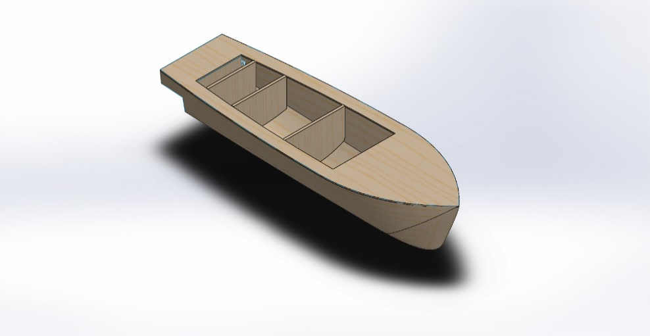

***Fig. 5.1*** *Isometric view*

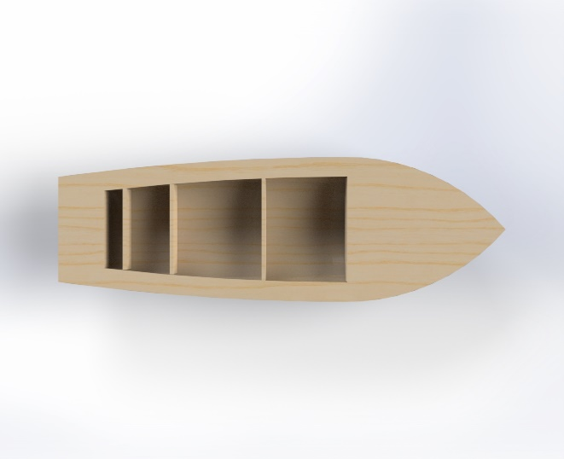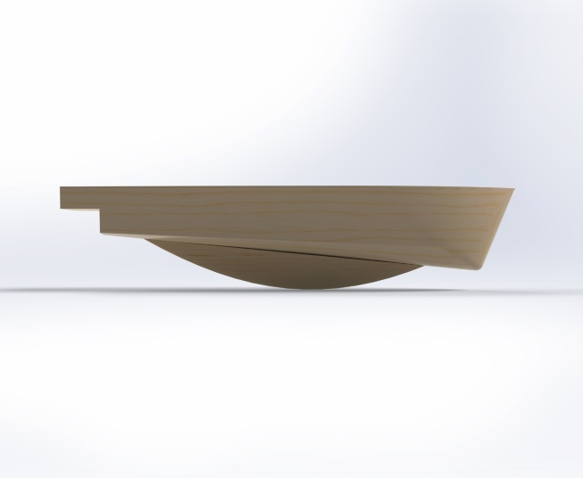

***Fig. 5.2*** *Top view* ***Fig. 5.3*** *Side View*

**5.3 WORK DONE**

As ship design and construction are time-consuming and tedious processes, various errors and inaccuracies are assessed right from the very early stages, by taking precautions and tests at each step.

**5.4 Fabrication of model ship**

**5.4.1 Planning of design and dimensions**

Ship design is a complex, iterative and multifaceted process, influenced by several factors. Based on the vision of project, we developed the cost-efficient ship for a designated task. New ship design of our project is based on existing vessel designs and on minor breakthrough innovations. The length of the vessel is 58.5cm and breadth of vessel is 18.5 cm.

**5.4.2 Selection of material to construct vessel**

Ship models are not made up of the same material as that of the main ship, i.e., mild steel or high strength steels. These ship models are generally small sized, they would not have the desired water plane area and the volume required to cater to the displacement and hence would sink due to their own weight. Thus, model is made up of Wood.

Since Balsa Wood is so light, it carves and bends easily and creates a light and fine dust when sanded, it is perfect for making model. When using Balsa wood for ship models, you can get by with a minimal tool arsenal. Balsa wood has a lower density, so we selected balsa wood for fabrication of ship model.

**5.4.3 Laying of Keel**

The keel is the bottom-most longitudinal structural element on a vessel. The keel is the primary structural member and backbone of the vessel which runs along the centerline of the bottom plate around which the hull of the ship is built as shown in Fig 1. The keel is often the first part of a ship's hull to be constructed, and laying the keel, or placing the keel in the cradle in which the ship will be built may mark the start time of its construction. We have used bar keel in our project.

***Fig.5.4*** *Laying of Keel*

**5.4.4 Construction of Hull**

There is a wide variety of hull types that are chosen for suitability for different usages, the hull shape being dependent upon the needs of the design. In our project we have used round bilge hull. Fig shows the constructed hull.

Steps involved in construction of hull,

* Laying of keel
* Frames are fitted to keel. Frames are ribs that are vertically fitted to the keel. Frames support the hull and give the ship its shape and strength.
* Laying strips along the bulkhead (skeleton of ship)
* Sharp edges are sanded using rasp and rough file
* Balsa wood has a "grain fuzz" that remain after being sanded so doping process is carried out
* To fill major dents metal paste is applied to the skeletal structure of hull. Excess metal paste is sanded off using sander machine.
* To fill minor dents putty work is carried out. Excess putty is wiped using water emery or with emery paper.
* Final stage is applying primer and painting the hull and finishing work is carried.





***Fig.5.5*** *Metal paste stage* ***Fig.5.6*** *Primer stage*

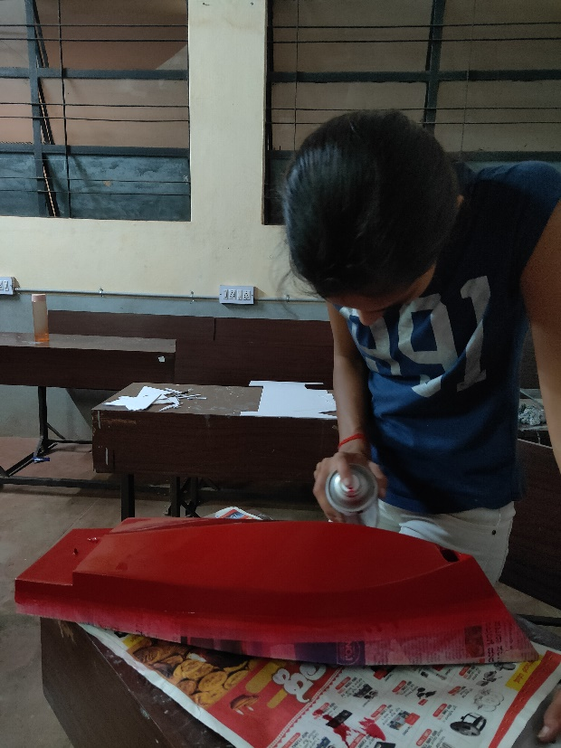

***Fig 5.7*** *Painting hull*

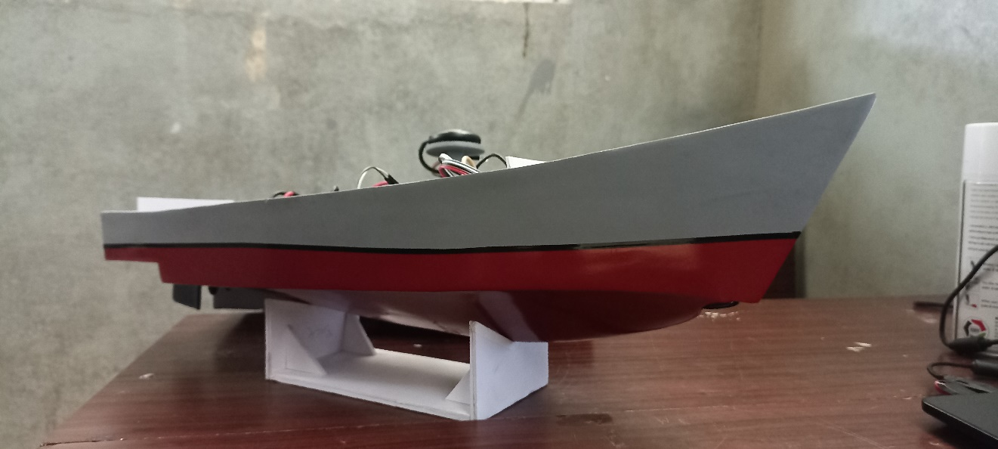

***Fig. 5.8*** *Hull*

**5.4.5 Construction of superstructure**

A superstructure is an upward extension of an existing structure above deck. On watercraft, the superstructure consists of the parts of the ship that project above her main deck. Process in construction of superstructure is same as that of hull.

In superstructure, the obstacle detection sensors such as ultrasonic sensor functioning as distance sensing module and the Antenna for wireless trans-receiver module.

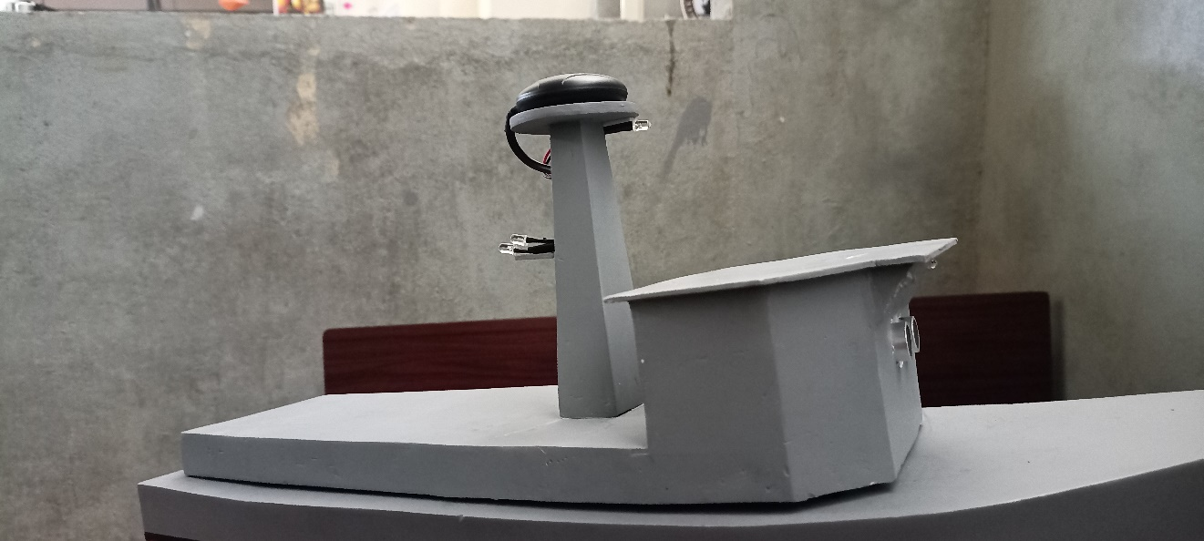

***Fig. 5.9*** *Superstructure*

**5.5 SETUP AND CONFIGURATION**

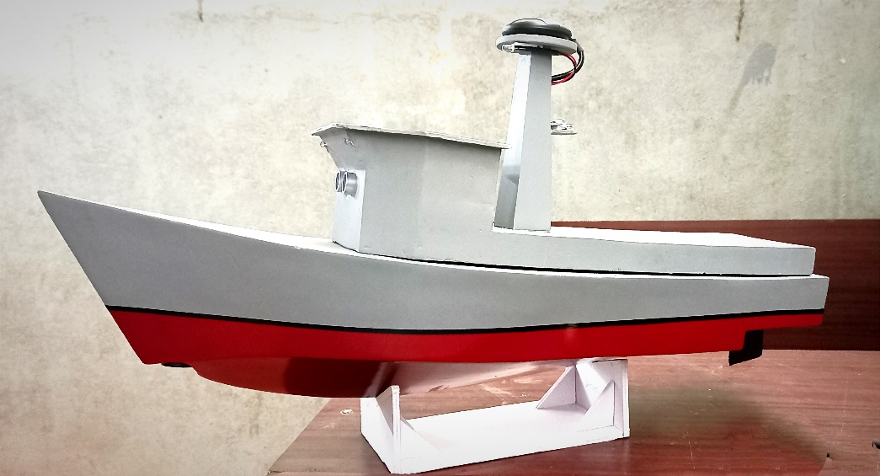

***Fig.5.10*** *Completed prototype model*

Connecting the components with flight controller and raspberry pi, pi camera which will be giving a video output from the model ship to then ground station.

Power bank module and lipo battery will be powering the whole system.

APM 2.8 which will be having RC receiver as input and controlling output as brushless DC motor and servo. APM will be equipped with GPS module that has external compass as well. This device helps us to automate the model ship and to propel in the proposed direction.

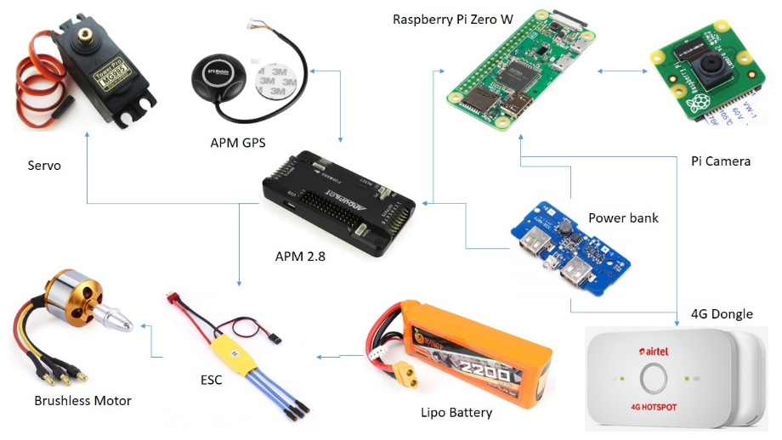

***Fig.5.11*** *setup and configuration*

**CHAPTER 6**

**RESULT AND DISSCUSSION**

**6.1 Result and Discussion**

A fully autonomous crewless prototype ship was designed and fabricated which runs on complete automation without any crew. Sensors, actuators, micro-controller that are feasible are selected and used in the project. It helps in sensing the surrounding areas, evaluates rough sea and weather conditions which helps in avoiding collision.. The advantages of autonomous ships are plentiful. They eliminate human erors, reduce crewing cost, increase the safety of life, and allow for more efficient use of space in ship design and efficient use of fuel.

Autonomous ships provide significant safety benefits, as 75% of maritime accidents are caused by human error with the leading cause being fatigue and attention deficit. As there is no crew that needs to go ashore for crew change, fully autonomous vessels can more easily adopt slow speed and save energy/fuel. They eliminate human error, reduce crewing costs, increase the safety of life and allow for more efficient use of fuels.

The sample of depth, distance, temperature, accelerometer and gyro data obtained from then sensors are as follows,

Connected! 0

["b'22", '124.64', ' -2220', '-16092', ' -2164', '27', ' 57', ' 68', " -107'"]

Depth: b'22

Range: 124.64

Temperature: 27

Accelerometer: X -2220 Y-16092 Z -2164

Gyro: X 57 Y 68 Z -107

The pitch roll and yaw data obtained from ardupilot is display on the GUI interface and is also exported as csv file. The screenshot of data is shown in fig 6.1

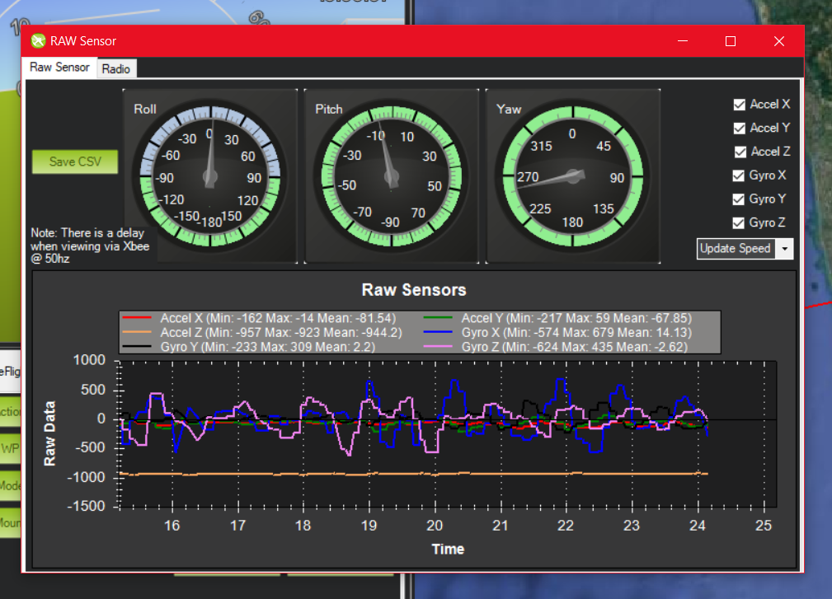

***Fig.*** *6.1 Pitch, roll and yaw*

The software interface of ardupilot which displays all the parameters such as changing modes and displaying map location etc. is shown in fig. 6.2

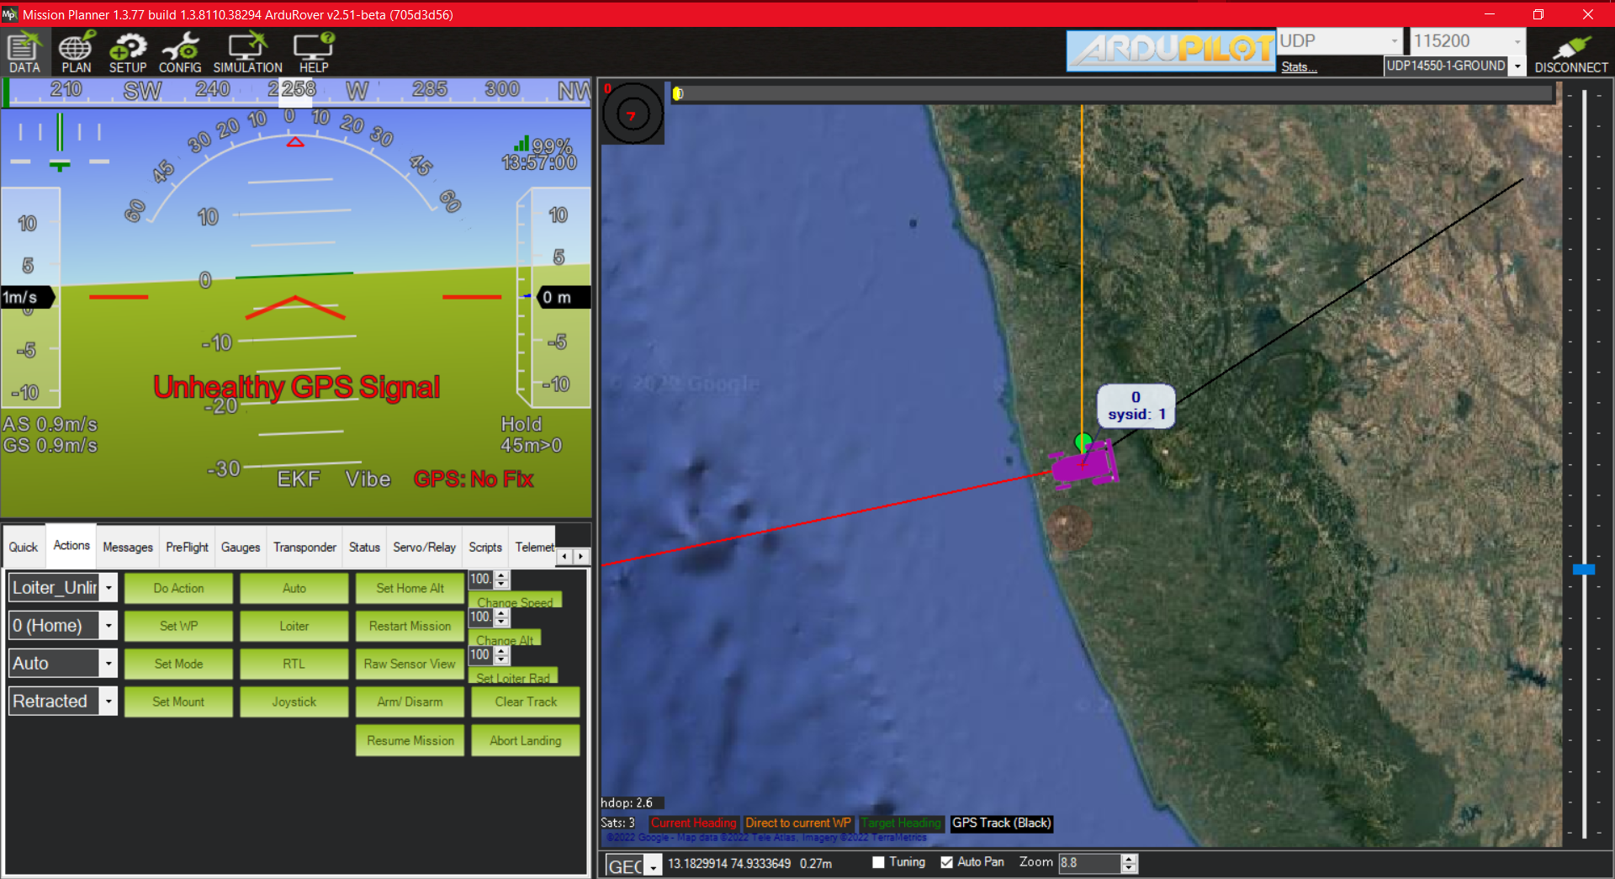

***Fig.*** *6.2 GUI interface*

**CHAPTER 7**

**CONCLUSION AND SCOPE OF FUTURE WORK**

**7.1 CONCLUSION**

From the literature review it can be concluded that there are many hurdles when it comes to implementing autonomous ships in international waters. Hurdles such as international maritime laws are not designed keeping for autonomous ships and role of the shipmaster becomes in case of an autonomous ship when the shipmaster is not onboard.

The system is operational and capable to avoid obstacles and enables autonomous functions like collision avoidance and position hold and change. Still, the system lacks of some drawbacks since the ultrasonic sensors only measured distances up to about 250cm reliably, Farer distances and problematic surfaces are not detected at all or with the necessary reliability. Improving the quality of the ultrasonic sensors and fusing these sensors with other systems like infrared is needed to improve the system. Since ultrasonic sensors fail to detect all surfaces, other sensors are mandatory.

**7.2 SCOPE OF FUTURE WORK**

A neural network model needs to be constructed for real time decision making for a ship to be fully autonomous without human interaction. A fully autonomous ship would be self-aware and capable of making its own choices. For the growth and sustainable development, cost efficient mechanisms of shipping are followed, especially in the developing world. They eliminate human erors, reduce crewing cost, increase the safety of life, and allow for more efficient use of space in ship design and efficient use of fuel.

The advent of autonomous ships that are unmanned or low-manned will reduce the number of people at risk at sea. Even when autonomous navigation does not reduce the number of accidents, this means that safety at sea will increase. In fact, increased safety is one of the primary perceived drivers for autonomous shipping, although this safety increase has not yet been quantified in academic literature. In this project a statistical analysis is performed to determine the distribution of human casualties and lost ships over accident types, ship types and ship sizes. Subsequently, based on several scenarios for the implementation of autonomous ships, a quantification of the estimated reduction in loss of life and loss of ships is provided. It is concluded that the implementation of autonomy on small cargo ships with a length below 120 m will have the largest safety benefit, since these ships account for the majority recorded ship losses and lives lost.

**REFERENCE**

1. Zhou, X., Huang, J., Wang, F., Wu, Z., & Liu, Z. A Study of the Application Barriers to the Use of Autonomous Ships Posed by the Good Seamanship Requirement of COLREGs. Journal of Navigation (2020), 73(3), 710-725. doi:10.1017/S0373463319000924
2. Goran Vojković, Melita Milenković. Autonomous ships and legal authorities of the ship master. Case Studies on Transport Policy (2020), Pages 333-340, ISSN 2213-624X, https://doi.org/10.1016/j.cstp.2019.12.001
3. T. J. McCoy, "Electric Ships Past, Present, and Future [Technology Leaders]," in IEEE Electrification Magazine, vol. 3, no. 2, pp. 4-11, June 2015, doi: 10.1109/MELE.2015.2414291
4. Munim, Ziaul Haque. "Autonomous ships: a review, innovative applications and future maritime business models." Supply Chain Forum: An International Journal. Vol. 20. No. 4. Taylor & Francis, 2019.
5. Kurt Schwehr. Vessel Tracking Using the Automatic Identification System (AIS) During Emergency Response: Lessons from the Deepwater Horizon Incident, Presented at US Hydro, Tampa Fl (2011). https://www.researchgate.net/publication/266447104
6. M.A. Ramos, I.B. Utne & J.E. Vinnem, A. Mosleh. Accounting for human failure in autonomous ship operations. Safety and Reliability – Safe Societies in a Changing World – Haugen et al. (Eds). Taylor & Francis Group, London, (2018) ISBN 978-0-8153-8682-7
7. Felski A, Zwolak K. The Ocean-Going Autonomous Ship—Challenges and Threats. Journal of Marine Science and Engineering. (2020); 8(1):41. <https://doi.org/10.3390/jmse8010041>
8. Ardupilot mission planner <https://ardupilot.org/planner>
9. Raspbian OS <https://www.raspberrypi.com/software/operating-systems>